
Land Information Ontario (LIO) Warehouse
Data Class Name: Waterpower Generation Station
Documentation
Produced by: Information Access and Information Management Policy Unit
Ministry of Natural Resources and Forestry
Date: July 27, 2015

Purpose

This document provides additional information to support the use of geospatial data. The Physical Model Diagram provides a visual representation of the relationships in the data class. The Data Change History lists all the modelling and access changes that have occurred during the lifecycle of the data class. A data description identifying table and field names is available upon request.

Need Assistance?
Please contact LIO Support at lio@ontario.ca or 705-755-1878 if you require help.

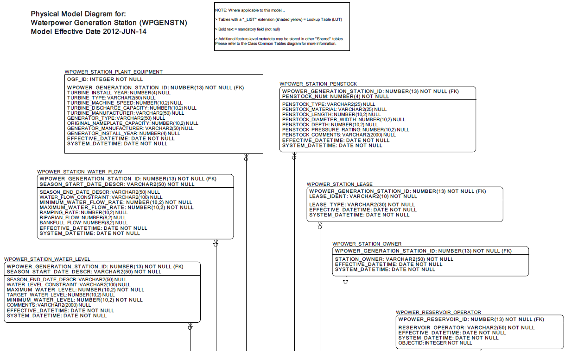

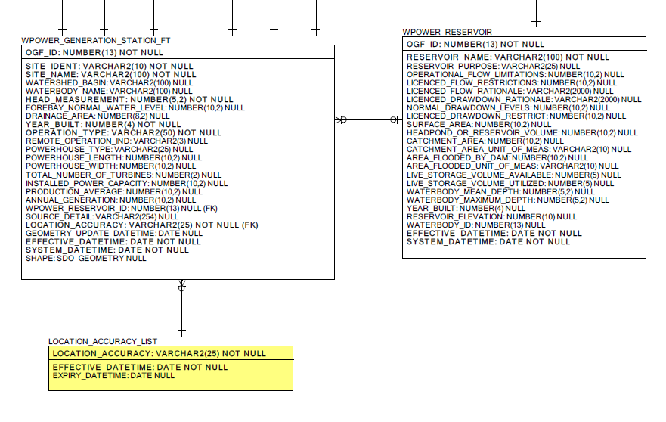

Data Class Change History
Data Class Name: Waterpower Generation Station
Data Class Short Name: WPGENSTN
Date  YYYY-MM-DD | Details of Change
2011-03-10 | Convert to Simple Data Class:  Table dropped: GEOG_UNIT. Geog Unit table and associated common tables dropped to change to simple data class.
2011-03-10 | Convert to Simple Data Class:  Added and renamed ‘Database Reference’ from common table structure. All data/processes currently available with the ‘Database Reference’ table are to be maintained. (Two Columns have been removed: ‘External Reference Type’, and ‘Type Other Description’).
2011-03-10 | Convert to Simple Data Class:  Added LOCATION_ACCURACY_LIST from common table structure to provide a location accuracy lookup selection list.
2011-03-10 | Column altered: WPOWER_GENERATION_STATION: Watershed_Basin  Column order changed, Watershed Basin moved between 'Site Name' and 'Waterbody Name'.
2011-03-10 | Convert to Simple Data Class:  Column Added: WPOWER_GENERATION_STATION: Location_Accuracy  Added foreign key attribute from the Location Accuracy List lookup table.
2011-03-10 | Convert to Simple Data Class:  Column Added: WPOWER_GENERATION_STATION:Source_Detail  Add 'Source Detail' field to capture notes related to the data source.
2003 | NEW Data Class
Data Description
Please refer to the metadata record for the data description.

